*ENM500 Petroleum Geoscience – Tutorial 1*

1. *Describe igneous rocks are formed*
2. *Explain how the magma cooling process will affect the characteristics of igneous rocks*
3. *Metamorphic and sedimentary rocks can be formed from igneous rocks. Explain how.*
4. *Explain the roles of rock forming minerals in the characterisation of igneous rocks*
5. *Give at least two examples each of intrusive and extrusive rocks*
6. *Analyse the Bowen reaction series with regards to mineral crystallisation from cooling magma*
7. *Two key conditions are important for the formation of a metamorphic rock. Give these conditions and describe their roles in the formation of a metamorphic rock*
8. *Explain the following types of metamorphic processes*
9. *Contact metamorphism*
10. *Cataclastic*
11. *Regional*
12. *Hydrothermal*
13. *Grade of metamorphic rocks are affected by temperature, pressure and depth of burial. Explain.*
14. *Provide the metamorphic rock equivalents of the following rocks*
15. *Quartz Arenite -*
16. *Limestone -*
17. *Granite -*
18. *Shale -*
19. *Describe the key stages of sedimentary rock formation*
20. *How does diagenetic process lead to formation sedimentary rocks? How is the process different from metamorphic process?*
21. *How does environment of deposition affect the reservoir properties and quality of sedimentary rocks?*
22. *What is sorting? Describe the influence of sorting on reservoir quality of sedimentary rock.*
23. *Briefly explain the following sedimentary rock features:*
24. *Cross bedding*
25. *Ripple marks*
26. *What is porosity? Differentiate between primary and secondary porosity; absolute and effective porosity*
27. *What is permeability? Show the relationship between absolute, relative and effective permeability*
28. *What are sedimentary basins? Briefly describe how they are formed*
29. *Describe the five major conditions required for hydrocarbon formation*
30. *Identify the structure shown in Figure Q20 below and briefly describe the process of its formation and importance in hydrocarbon accumulation*

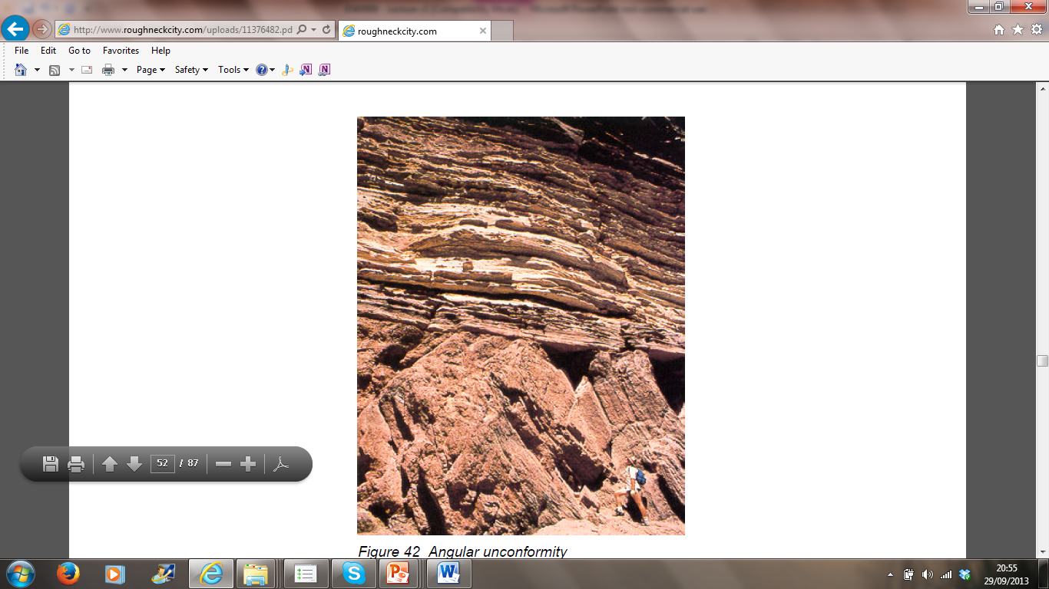

*Figure Q20*

1. *Briefly explain the major techniques used in exploring for oil and gas*
2. *Differentiate between wildcat and exploration well*
3. *Draw the cross section of the rocks represented by the contour map in Figure Q23 along the profile AB*



*Figure Q23 Contour map*

1. *Draw the cross section of the rocks represented by the contour map in Figure Q24 along the profile NS*

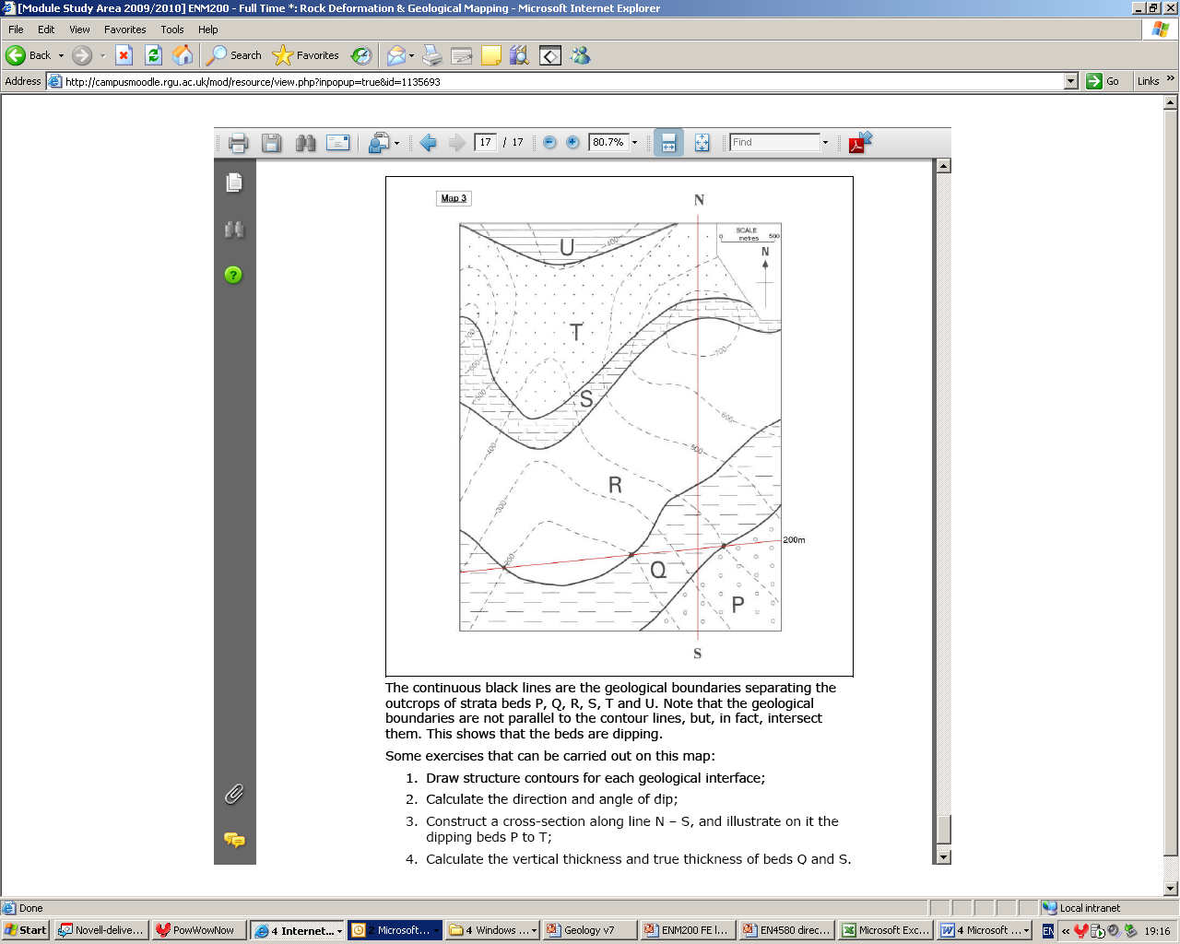

*Figure Q24 Contour map*

1. *Delineate the reservoir formation and determine the fluid contacts in Figure Q25 below*



Figure Q25 – Well log

1. *Determine the NTG for Well 211/29-C16, Well 33/12-B-39and Well 34/7-7 in Figure Q26 below*

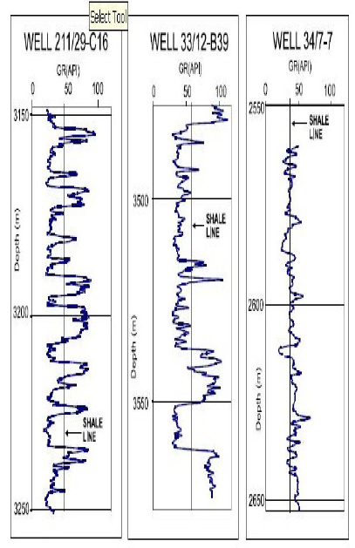

Figure Q26 – Well log